A celebration of student’s success over the last 12 months Appendix '4B'

Client | Location | Date | Time | Attendees | Contact
Eric Wright Trust / Preston’s College | Preston North End Football Club | 3rd May 2017 | 6pm – 8pm | 170 in total | Debbie Ireland / Diane Bourne

Overview
The Eric Wright Learning Foundation opened in 2005 and sponsors a ‘real work environment’ in partnership with Preston’s College. This is attended by students from age 14+ studying Level 1 to Level 3 vocational skills programmes, through to apprenticeships. Courses include carpentry and joinery, bricklaying and painting and decorating.  Each year the Eric Wright Learning Foundation, in partnership with Preston’s College, hold an awards evening to celebrate the success of the students over the previous 12 months.  This year we had 170 people attending the event which included learners, parents, carers, school representatives, | Preston’s College and Trustees from the Eric Wright Trust (Eric Wright Group).  34 learners were presented with awards which included 11 construction awards for learners at the Eric Wright Learning Foundation.  This year included a new award – The Partnerships School Award presented to Catherine Ashcroft from Shaftesbury High School in Chorley.  Year 10 and 11 winners were presented with a certificate, star award trophies and a branded torch and overall winners received a £50 voucher, certificate and the much sought after shield.
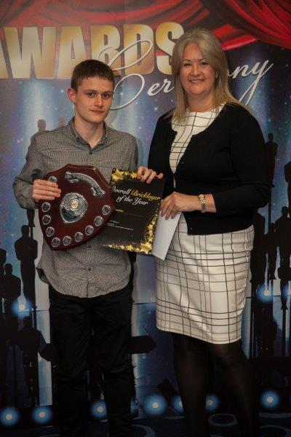
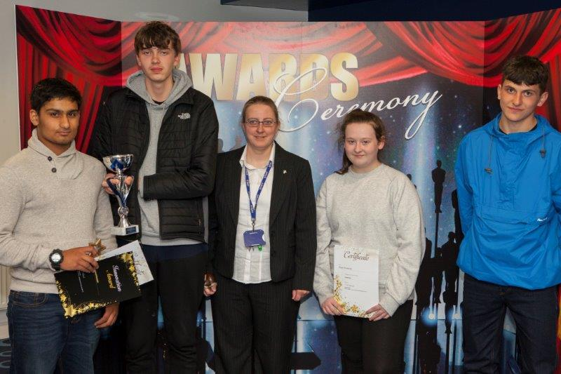
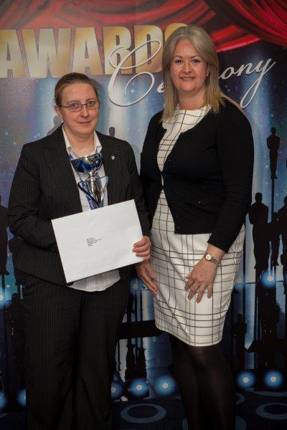
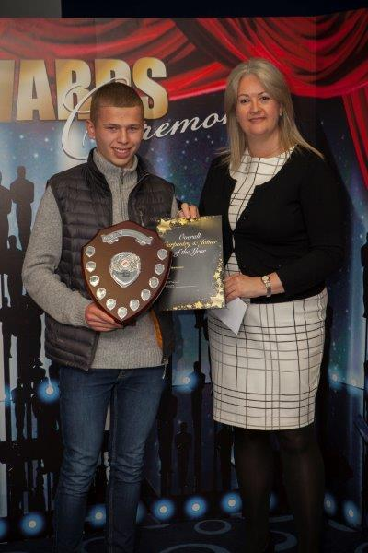
Overall Winners Awards
Carpentry and Joiner of the Year – Jack Hampson, Leyland St Mary’s
Bricklayer of the Year – Jack Deacon, Brownedge St Mary’s
Painter and Decorator of the Year – Bailey Helm – Leyland St Mary’s
Partnerships School Award – Shaftesbury High School

“The building is the final piece of the Spinningfields puzzle – a dazzling office that is anything but corporate and proof that designing on a budget can still create something unusual and inventive.”
- Mark Keegan, Senior Associate, Levitt Bernstein Associates

